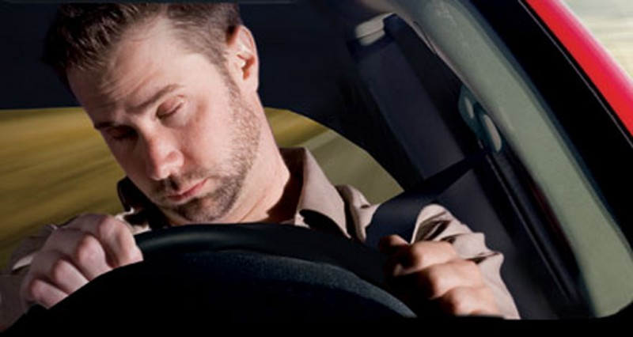

Are you feeling sleepy while driving?

No worries

NO-SLEEPY will help you